CZESTOCHOWA UNIVERSITY OF TECHNOLOGY
Faculty of Electrical Engineering
Institute of Computer and Information Sciences
MASTER'S THESIS
M.Sc. in Artificial Intelligence
AI-Based Optimal Solver for the 3x3 Rubik's Cube
Author: Edward Ogbei
Student ID: s47891
Supervisor: Prof. dr hab. inz. Krzysztof Rojek
Year: 2025/2026
Czestochowa, 2026

Table of Contents
1. Introduction 4
2. Aim of the Work 6
3. Theoretical Background 8
3.1 The Rubik's Cube as a Mathematical Object 8
3.2 Classical Solving Algorithms 10
3.3 AI-Based Approaches 10
4. System Architecture 12
4.1 Cubie-Level State Representation 12
4.2 Move Tables 13
4.3 Legality Constraints 14
4.4 State Encoding for Neural Networks 14
5. Solving Strategies 16
5.1 The BFS Expert Solver 16
5.2 Neural Network Architecture 16
5.3 Greedy Inference 18
5.4 Beam Search 19
6. Dataset Generation and Curriculum Training 20
6.1 Dataset Generation 20
6.2 The 80 Percent Replacement Strategy 22
6.3 Training Procedure 23
6.4 Training Outcomes - Depth by Depth 26
6.5 Implementation Notes 27
7. Web Visualisation System 29
7.1 Server Design 29
7.2 Three.js 3D Frontend 29
8. Experimental Evaluation 32
8.1 Evaluation Methodology 32
8.2 Solve Rate Results 32
8.3 Timing Analysis 33
8.4 Discussion 34
9. Conclusions and Future Work 35
Bibliography 38
Appendix A - List of Figures 39
Appendix B - List of Tables 40
Appendix C - List of Abbreviations 41
Streszczenie (Polish Abstract) 42
Abstract (English) 43
Author's Declaration 44

1. Introduction
The Rubik's Cube serves as an ideal test domain due to its unique combination of physical simplicity and computational complexity, presenting a challenge that resists brute-force search methods.
The primary interest from a computer science perspective lies in the structure of the Rubik's Cube's state space rather than its commercial appeal. A standard 3x3 Rubik's Cube possesses exactly 43,252,003,274,489,856,000 distinct reachable configurations - approximately 43 quintillion. Despite this vast number, every configuration can be solved in at most 20 face moves. This result, known as God's Number, was established computationally in 2010 by Rokicki et al.^{[1]} using approximately 35 CPU-years of computation distributed across Google's servers. The contrast between the immense problem space and the compactness of its solution highlights the Rubik's Cube as a natural benchmark for search and optimisation algorithms.
Classical approaches to solving the Rubik's Cube are well established and provide a critical baseline for comparative analysis.
A central research question is whether a learning system can discover how to solve the cube without explicit domain knowledge. This forms the basis of the imitation learning approach, which involves generating numerous (scrambled state, correct next move) pairs using an expert solver and training a neural network to predict the next move from the current state. The primary challenge is generalising from a finite training set to the vast state space. This task is complicated by the enormity of the cube's state space, the highly non-local relationship between state and optimal move, and the tendency of naive training methods to fail on deeper scrambles.
Curriculum learning was selected as the training strategy, inspired by the incremental manner in which humans acquire complex skills - beginning with simpler tasks and progressively increasing difficulty.
This thesis presents a comprehensive system developed from the ground up, encompassing all components from the cube simulation engine to the web-based user interface.

The scope of the project is intentionally limited to neural inference, explicitly excluding planning algorithms such as MoThe remainder of the thesis is structured as follows: Chapter 2 outlines the research objectives; Chapter 3 presents the theoretical background, including the group structure of the cube and relevant prior work; Chapter 4 details the cube representation and move tables; Chapter 5 discusses both classical and neural solving strategies; Chapter 6 describes the training data generation and learning process; Chapter 7 introduces the web visualisation system; Chapter 8 reports experimental results; and Chapter 9 concludes with a discussion of limitations and future directions.s and future directions.
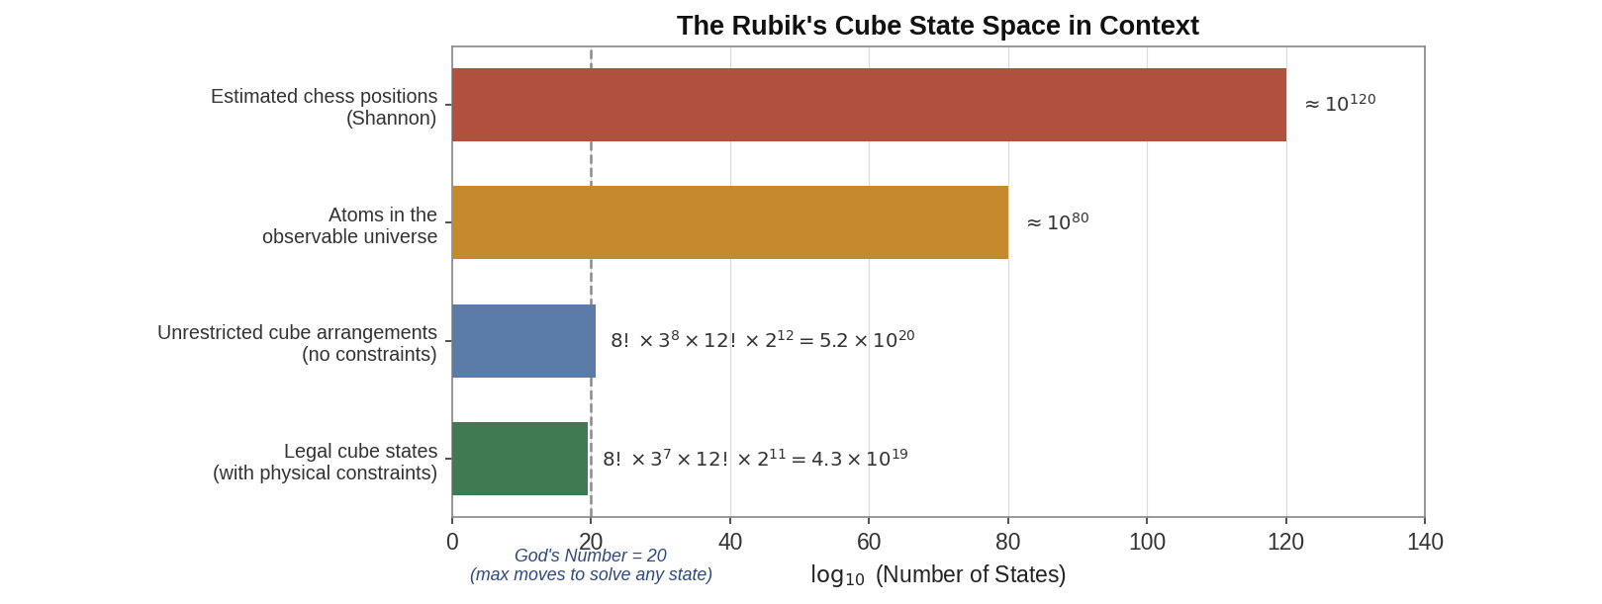

Fig. 1.1. Illustration of the Rubik's Cube state space and the concept of solving depth. Each node represents a cube configuration and each edge a single face move

2. Aim of the Work
The Rubik's Cube presents a well-defined combinatorial optimization challenge: given an arbitrary scrambled configuration, the task is to find a sequence of legal face moves that returns the cube to the solved state. This challenge is not solely technical; it also raises broader questions regarding the types of structured knowledge that a neural network can acquire through imitation and the impact of curriculum design on generalization.
The central research question is whether a small, fully-connected neural network can learn an effective solving policy for the Rubik's Cube through imitation of an exact solver. The primary hypothesis is that curriculum training, which begins with shallow scrambles and progresses to deeper ones, yields substantially better generalization than training on all depths simultaneously. A secondary hypothesis is that beam search, by exploring multiple candidate paths, improves upon the greedy policy, particularly for mid-depth scrambles where the greedy approach begins to fail.
This work pursues three practical objectives. The first objective is to implement a complete and mathematically verified 3x3 Rubik's Cube engine, including a cubie-level state representation, a full 18-move set, and automated checks for all group-theoretic legality constraints. The second objective is to construct a training pipeline that generates curriculum datasets using an expert BFS solver and trains the multi-layer perceptron (MLP) at successive depth levels. The third objective is to deliver an interactive web visualization that enables real-time demonstration of both solvers, featuring animated moves and a benchmark comparison tool.
The scope of the work is bounded in several important ways. The neural solver targets scramble up to 8 moves in depth. The expert solver is a bidirectional BFS implementation, which is optimal for shallow depths but does not scale to the full cube - it is not the Kociemba two-phase algorithm, which would require substantially more engineering effort to implement correctly. The neural network architecture is intentionally simple (a three-hidden-layer MLP with roughly 184,000 parameters) to keep training feasible on a standard CPU and to maintain interpretability. No GPU training was assumed, though the code supports CUDA automatically when available.

The core claim is that curriculum learning constitutes a viable strategy for training a neural solving policy on a well-structured combinatorial puzzle. To evaluate and demonstrate this claim, all supporting infrastructure, including the cube engine, the training pipeline, and the interactive visualization, was developed.

3. Theoretical Background
This chapter presents the mathematical foundations and key concepts required to understand the project, and positions it within the existing literature on Rubik's Cube solving and machine learning for combinatorial problems.

3.1 The Rubik's Cube as a Mathematical Object
Mathematically, the cube is a permutation group: each move transforms the group element. The set of all reachable configurations, together with the operation of applying a face move, forms a group under composition. This group - sometimes called the Rubik's Cube group - is a subgroup of the symmetric group on 48 movable facelets (excluding the 6 fixed centres). Its order is exactly 43,252,003,274,489,856,000, a number that can be derived by counting the independent degrees of freedom ^{[5].}
Concretely, the cube has 8 corner pieces and 12 edge pieces. Each corner can be placed in any of 8 slots (8! arrangements) and can have one of 3 orientations, giving 8! * 3^8 corner states if unconstrained. Similarly, each edge can occupy any of 12 slots with one of 2 orientations, giving 12! * 2^12 edge states. However, not all combinations are reachable from a legal starting configuration. Three constraints reduce the total count by a factor of 12: the sum of all corner orientations must be divisible by 3; the sum of all edge orientations must be divisible by 2; and the permutation parity of the corners must equal the permutation parity of the edges. These invariants are preserved by every legal face move and are central to verifying the legality of any given state.
A key result, known as God's Number, states that the hardest scrambles need at most 20 moves. This bound serves as a useful benchmark. For the standard outer-layer turn metric it is 20, for the quarter-turn metric (where 180-degree turns count as two) it is 26. The proof for the face-turn metric was completed computationally in 2010^{[1]}. The distribution of states by depth follows a roughly Gaussian shape peaking around depth 17-18, with the vast majority of configurations reachable in 15 to 19 moves. This distribution explains why random scrambles of fewer than 8 moves represent only a tiny corner of the full state space.

$$N =\frac{8! ×3^{7}×12! ×2^{11}}{2}≈4.3 ×{10}^{19}$$

For algorithmic purposes, the cube is typically represented at the cubie level rather than the facelet level (54 coloured stickers). Each corner is specified by the three colours it possesses (for example, the URF corner contains white, red, and green in the standard colour scheme) and its orientation with respect to a canonical reference direction. Edges are identified in an analogous manner. This cubie-based representation is more compact and corresponds naturally to the algebraic structure of the cube group.

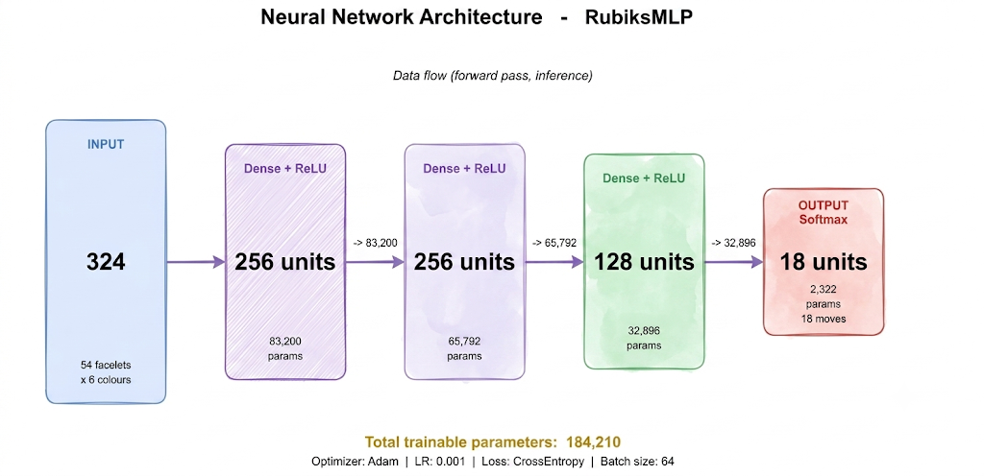
Fig. 4.1. Cubie-level state representation using corner permutation (cp), corner orientation (co), edge permutation (ep), and edge orientation (eo). This is more compact than facelet representation.
def apply_move(self, move_idx):
perm_c, perm_e, twist_c, flip_e = MOVE_PERMUTATIONS[move_idx]
self.corners = [self.corners[i] for i in perm_c]
self.edges = [self.edges[i] for i in perm_e]
self.corner_orient = [(self.corner_orient[perm_c[i]] + twist_c[i]) % 3 for i in range(8)]
self.edge_orient = [(self.edge_orient[perm_e[i]] + flip_e[i]) % 2 for i in range(12)]

3.2 Classical Solving Algorithms
Breadth-first search (BFS) is the simplest exact search method. Starting from the scrambled state, BFS explores nodes one level at a time, which guarantees the shortest solution. However, it is limited by the number of possible moves at each step: there are 18, but this can be reduced to about 15 with move pruning. As a result, BFS checks around 15^d nodes to solve a scramble of depth d. For d = 10, this means about 576 billion nodes, making BFS impractical for most uses. Bidirectional BFS, which searches from both the scrambled and solved states at the same time, cuts the search space to about 2 × 15^{(d/2)} nodes, so d = 14 is possible with reasonable memory and computing power.
Iterative deepening A* (IDA*) ^{[6]} solves the memory problem of BFS by using a depth-limited depth-first search that increases the depth limit step by step. With an admissible heuristic (one that never overestimates the true distance to the solution), IDA* finds optimal solutions without storing the whole search tree. The Kociemba two-phase algorithm ^{[2]} uses this idea by splitting the cube group into two subgroups. In the first phase, it finds a sequence that moves the cube into a restricted subgroup (where edges are oriented correctly and UD-slice edges are in place). The second phase solves the cube within this subgroup. Both phases use IDA* with precomputed lookup tables. This method reliably finds near-optimal solutions in milliseconds and without randomness, setting a standard for exact solving methods.
Human-oriented methods such as CFOP (Cross, F2L, OLL, PLL) decompose the solution process into clear, memorisable steps. While these methods are not optimal - typically requiring 50 to 80 moves to solve the cube - they are practical and enable speedcubers to achieve solve times under five seconds. Although these techniques are not employed in this project, they illustrate how individuals approach the problem by partitioning it into manageable sub problems.

3.3 AI-Based Approaches
A review of previous research was conducted to establish the current state of knowledge and to identify remaining gaps. Imitation learning was selected as the primary approach because it enables direct training from expert demonstrations and offers greater sample efficiency than reinforcement learning for structured combinatorial problems. The following sections discuss these approaches in detail.
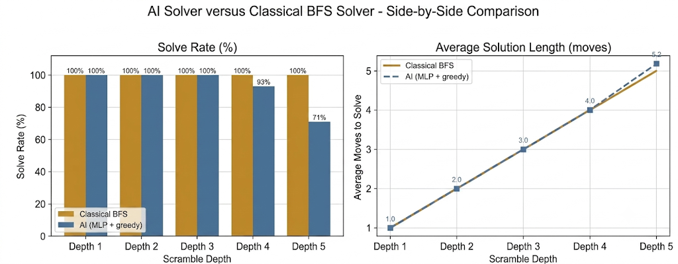

Fig. 3.1. Overview of the relationship between classical expert solvers and the neural network imitation pipeline. The expert generates labels; the network learns to imitate.

4. System Architecture
This chapter details the design of the cube simulation engine, which serves as the mathematical foundation of the project. All other components, including the solvers, training pipeline, and visualization, rely on this engine for state representation and move application.

4.1 Cubie-Level State Representation
The cube state is encoded using four integer arrays according to the Kociemba coordinate system ^{[2]}. The corner permutation array (cp), of length 8, specifies which corner piece occupies each slot, using integer identifiers from 0 to 7. Corners are designated by their three adjacent faces: URF (Up-Right-Front), UFL, ULB, UBR, DFR, DLF, DBL, and DRB. In the solved state, cp[i] equals i foThe corner orientation array (co), also of length 8, assigns values of 0, 1, or 2 to indicate the twist of each corner relative to the U/D axis. An orientation value of 0 indicates the reference facelet is facing up or down, 1 corresponds to a 120-degree clockwise rotation, and 2 corresponds to a 120-degree counter-clockwise rotation. This three-value encoding is specific to corners due to their three-fold. Two analogous arrays represent the edges. The edge permutation array (ep), of length 12, records which edge piece occupies each slot. The edges are named UR, UF, UL, UB, DR, DF, DL, DB, FR, FL, BL, and BR. The edge orientation array (eo), also of length 12, assigns 0 to correctly oriented edges and 1 to flipped edges. The six face centers act as fixed reference frames and are not stored in any array; they implicitly define the color assignment for each slot. The class is intentionally minimal and contains no visualisation logic, functioning solely as a mathematical model.; it is a pure mathematical model.
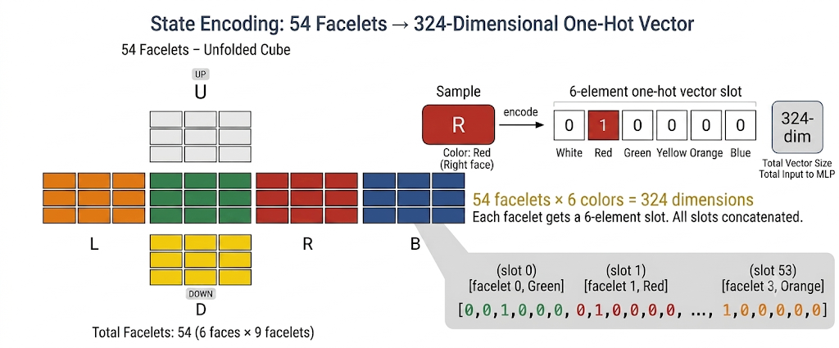
Fig. 4.1. The cubie-level state representation. Corner permutation (cp), corner orientation (co), edge permutation (ep), and edge orientation (eo) together fully describe any legal cube configuration.

4.2 Move Tables
In the standard half-turn metric, the cube has 18 moves: six basic face turns (U, D, R, L, F, B), their inverses (U', D', R', L', F', B'), and their 180-degree versions (U2, D2, R2, L2, F2, B2). Each move is encoded as a MoveDefinition object that contains four tuples: corner permutation, corner orientation delta, edge permutation and edge orientation delta.
The six basic moves are manually defined in the Kociemba convention. For example the U move cycles corners like this : URF -> UBR -> ULB -> UFL -> URF and edges like this : UR -> UB -> UL -> UF -> UR . A U move does not change the orientation of the corners and edges because the reference facelet (the one that is on the U or D face) remains on the U or D face after the turn. This is not the case for F and B moves, where edges that were on U or D faces end up on L or R faces and are flipped in orientation.
The prime (inverse) and double moves are computed algebraically by composing the base move with itself. The function compose_moves implements the group product . Given two move definitions A and B , the composition B then A is computed by applying the permutation B first , and then A. Orientation deltas are added modulo 3 (for corners) or modulo 2 (for edges). This method guarantees internal consistency, move tables form closed group under composition.
The B and L move definitions were the most prone to errors during development. The B move is clockwise when looking at the back of the cube (counter-intuitive when writing the code from the front). An early version had the B move do a mathematically counter-clockwise corner cycle along with the correct edge cycle. This created a subtle visual shear in the 3D renderer that was initially difficult to diagnose. The solution was to carefully check the definition of each move by applying it four times and seeing if this results in the identity.

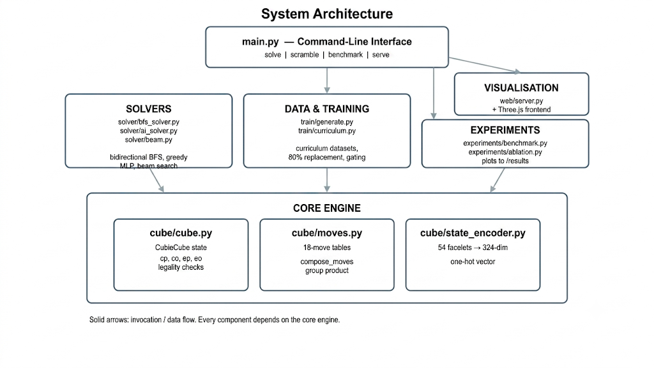
Fig. 4.2. High-level system architecture showing the relationships between the cube engine, the solvers, the training pipeline, and the web visualization.

4.3 Legality Constraints
Not every arrangement of corner and edge pieces represents a legal cube state, which is defined as a configuration attainable through a sequence of face moves from the solved position. The is_legal() method verifies three invariants that are preserved by all legal moves.
The first invariant requires that the sum of all corner orientations be divisible by 3. Each move alters corner orientations so that the total remains zero modulo 3. If a corner is removed and reinserted with a twist, this invariant is violated, rendering the cube unsolvable.
The second invariant stipulates that the sum of all edge orientations must be divisible by 2, as legal moves only flip edges in pairs. The third invariant mandates that the permutation parity of corners matches that of the edges; swapping two corners without affecting edges produces an illegal state. Collectively, these invariants reduce the theoretical state count by a factor of 12, resulting in 43.25 quintillion legal states.

4.4 State Encoding for Neural Networks
To hand a cube state to the network, the 54-character facelet string is turned into a one-hot vector. Each of the 54 facelets is one of 6 colours (U/white, R/red, F/green, D/yellow, L/orange, B/blue), so it becomes a length-6 vector with a single 1 in the slot for its colour. Stacking all 54 gives a 324-dimensional input (54 x 6 = 324), every entry either 0.0 or 1.0, with exactly 54 ones in any valid encoding.
The encoding is plain, but it holds everything needed to pin down the state. What it does not do is exploit the cube's group structure: two states related by a symmetry generally get different encodings unless the symmetry happens to be the identity. Richer coordinate encodings (twist, flip, UD-slice position) exist, but they were left aside here, since the point was to see how far a network could get from raw facelet data.
$\vec{x}∈R^{324}, \vec{x}=\left[x_{1}^{0},x_{1}^{1},…,x_{54}^{5}\right]$
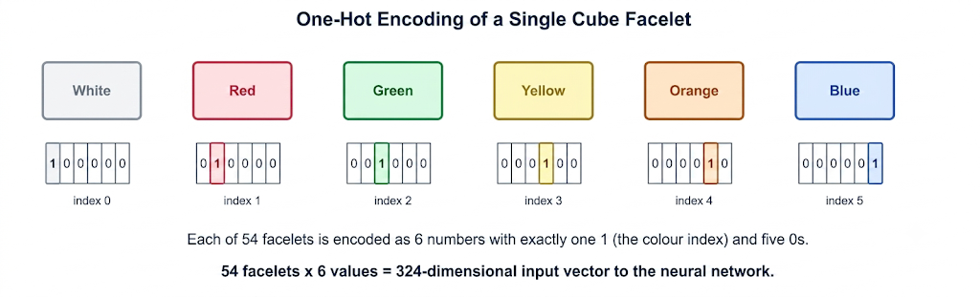
Fig. 4.4. One-hot encoding of a single cube facelet. Each of 54 facelets is encoded as 6 numbers with exactly one 1 (the colour index) and five 0s, giving a 324-dimensional input vector.

5. Solving Strategies
This chapter discusses three components of the solution: the BFS-based expert solver, which is used for both training labels and as a baseline; the greedy neural network solver; and the beam search extension.

5.1 The BFS Expert Solver
The expert solver implemented in this work utilizes a bidirectional BFS algorithm. This approach maintains two frontiers: one expands forward from the scrambled state, while the other expands backward from the solved state. The search terminates when the two frontiers intersect. The solution is constructed by concatenating the forward path with the inverse of the backward path.
Move pruning trims the branching factor by ruling out moves that lead nowhere useful. Two turns of the same face in a row are pointless, since R followed by R' simply cancels. Opposite faces are restricted to a fixed order too, so R is allowed after L but not the reverse, because the two commute and either order reaches the same place. With these rules the branching factor starts near 15 on the first move and falls off after that. On time alone, bidirectional BFS with this pruning is workable to about depth 14, but memory becomes the real limit past depth 9 or 10.
It is worth being clear about what this solver is and is not. It is not the Kociemba two-phase algorithm. Kociemba runs IDA* against precomputed pruning tables organised around two nested subgroups of the cube group, and it reliably returns sub-25-move solutions in milliseconds for any scramble. The BFS here is correct and optimal, but in practice it tops out around 8 to 9 moves before hitting the default 30-second limit. For what this project needs, training data for scrambles up to depth 8, that is enough.
Note: the naming convention 'Kociemba solver' used in parts of the codebase and UI is a simplification. The underlying implementation is bidirectional BFS, not the true Kociemba algorithm. This distinction is relevant when evaluating the system's claims about optimality for deeper scrambles.

5.2 Neural Network Architecture
The network is a fully-connected multi-layer perceptron. It takes a 324-unit input, runs it through three hidden layers of 256, 256, and 128 neurons with ReLU activations, and ends in an 18-unit output, one per legal move. Those outputs are raw logits; a softmax at inference time turns them into move probabilities.

Altogether the model has about 184,210 parameters. The first layer accounts for 324 x 256 + 256 = 83,456, the second for 256 x 256 + 256 = 65,792, the third for 256 x 128 + 128 = 32,896, and the output layer for 128 x 18 + 18 = 2,322. That is small by current standards, and intentionally so: the aim was training that finishes in hours on a CPU rather than days, and a model simple enough to reason about.

ReLU was preferred to sigmoid or tanh for the familiar reasons, it avoids vanishing gradients and is cheap to compute. There is no dropout or batch normalisation. At this size, the curriculum produces enough data that overfitting never really becomes a problem.
$$ReLU\left(x\right)=\max{(0,x )}$$
$${\hat{y}}_{i}=\frac{e^{z_{i}}}{\sum_{j=1}^{18}{}e^{z_{j}}}, \sum_{i=1}^{18}{}{\hat{y}}_{i}=1$$
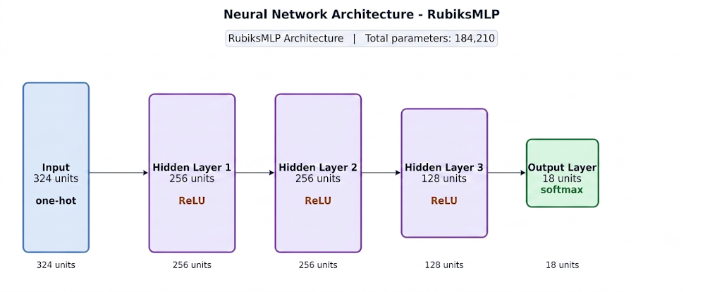
Fig. 5.1. RubiksMLP architecture: 324-dimensional one-hot input, three hidden layers (256, 256, 128) with ReLU activations, and an 18-unit softmax output layer. Total parameters: 184,210.

import torch
import torch.nn as nn
class RubiksMLP(nn.Module):
def __init__(self):
super().__init__()
# Four fully-connected layers. The input is the 324-dim one-hot
# cube encoding (54 facelets x 6 colours); the output is 18 logits,
# one per legal move.
self.fc1 = nn.Linear(324, 256) # input layer -> hidden 1
self.fc2 = nn.Linear(256, 256) # hidden 1 -> hidden 2
self.fc3 = nn.Linear(256, 128) # hidden 2 -> hidden 3
self.fc4 = nn.Linear(128, 18) # hidden 3 -> output (18 moves)

def forward(self, x):
# Pass the input through each hidden layer, applying a ReLU
# activation after each one to introduce non-linearity.
x = torch.relu(self.fc1(x)) # hidden layer 1 + ReLU
x = torch.relu(self.fc2(x)) # hidden layer 2 + ReLU
x = torch.relu(self.fc3(x)) # hidden layer 3 + ReLU
# Return raw logits. No softmax here; it is applied later at
# inference time (or folded into the cross-entropy loss in training).
return self.fc4(x)

5.3 Greedy Inference
At inference time the greedy solver runs the current state through the network and applies whichever move has the highest softmax probability. It repeats this until the cube is solved or it hits a step cap (50 by default). It is quick, a single forward pass is roughly 0.5 to 2 milliseconds on CPU, but it has one real weakness: once it makes a wrong move, there is no way back. If a prediction pushes the cube further from solved, nothing downstream can notice the mistake and undo it.
The greedy solver is dependable up to depth 3 or 4, where the model is confident and slips are rare. At depth 5 the success rate falls to 77%, and past depth 6 it drops away fast. One quirk is that it sometimes over-solves, using more moves than the scramble depth, which suggests the model occasionally wanders before finding the way in. For the solves that do succeed, the average length stays close to the scramble depth, so the paths it learns are usually near-optimal.

5.4 Beam Search
Beam search gets around the no-going-back problem of greedy decoding by keeping several candidate paths alive at once. At each step every path in the beam is extended by its top-k most probable moves, where k is the beam width. The new candidates are scored by cumulative log-probability, and only the best beam_width of them survive. As soon as any path reaches the solved state, it is returned.
A visited-state set stops the search from coming back to a configuration it has already seen down a different path, which would otherwise create cycles. This matters because the model can fall into short loops, repeating the same two or three moves, and without that check it would never break out.
At beam width 5, the search reaches 89% at depth 5 and 50% at depth 6, against 77% and 31% for greedy. The price is compute: each step needs beam_width forward passes instead of one, and the visited-state set keeps growing. A depth-5 scramble runs in about 11 milliseconds with beam search versus 2.3 for greedy, fine for interactive use but a bottleneck for large-scale evaluation.
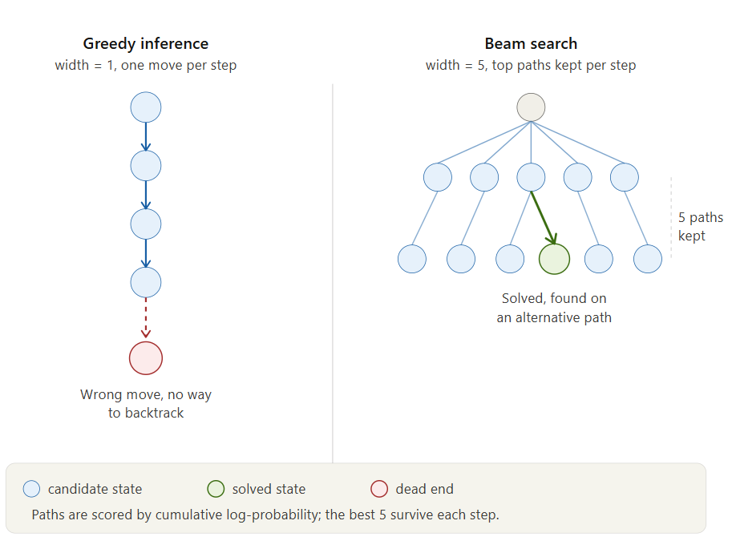
Fig. 5.2. Beam search tree with width 5. At each step, all paths are extended and the top-5 by cumulative log-probability are retained. Solved paths exit immediately.

6. Dataset Generation and Curriculum Training
This chapter explains how the training data is produced and how the model is trained. The two are bound together: the curriculum decides not only the training schedule but also the make-up of the dataset.

6.1 Dataset Generation
Each training sample mirrors the task the model has to perform: given a scrambled cube, name the next optimal move. To make one, a cube is scrambled with d random moves (d being the target depth), the expert BFS solver finds the full solution, and the first move of that solution becomes the label. The cube state at that point is the input. That gives one (state, label) pair per sample.
Scramble generation takes care not to undo itself. A depth-d scramble draws d moves uniformly from the 18, with the rule that no two consecutive moves touch the same face. This keeps scrambles that genuinely need d moves to solve; something like R R' R has an effective depth of 1, not 3, and would give the model the wrong idea about how hard the task is.
Datasets are saved as compressed NumPy archives (.npz), each holding three arrays: states (N x 324, float32), labels (N, int64, values 0 to 17), and depths (N, int32). At the top setting, the depth-8 dataset holds around 150,000 samples and takes up roughly 60 megabytes.

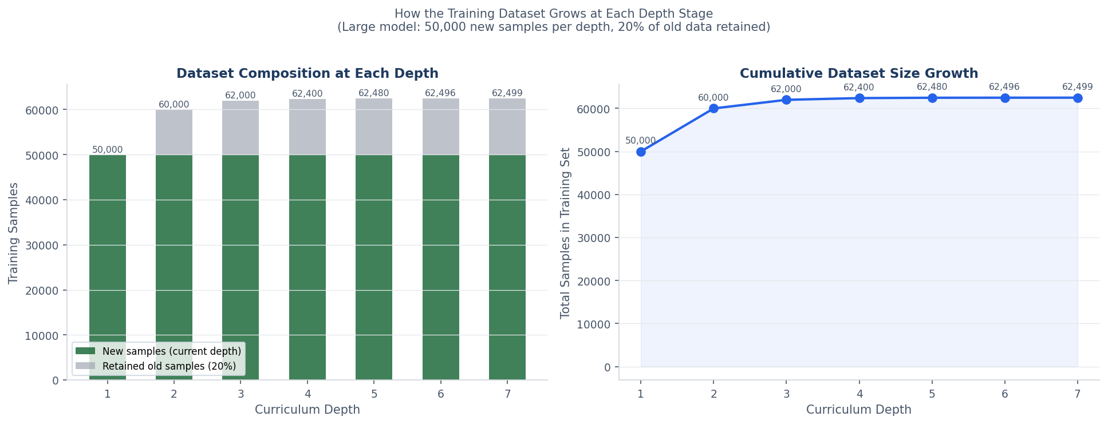
Fig. 6.1a. Dataset composition and growth at each curriculum depth stage.
Left: stacked bars show new samples (forest green) and retained old samples (grey).
Right: total dataset size grows to over 290,000 samples by depth 7 for the large model.

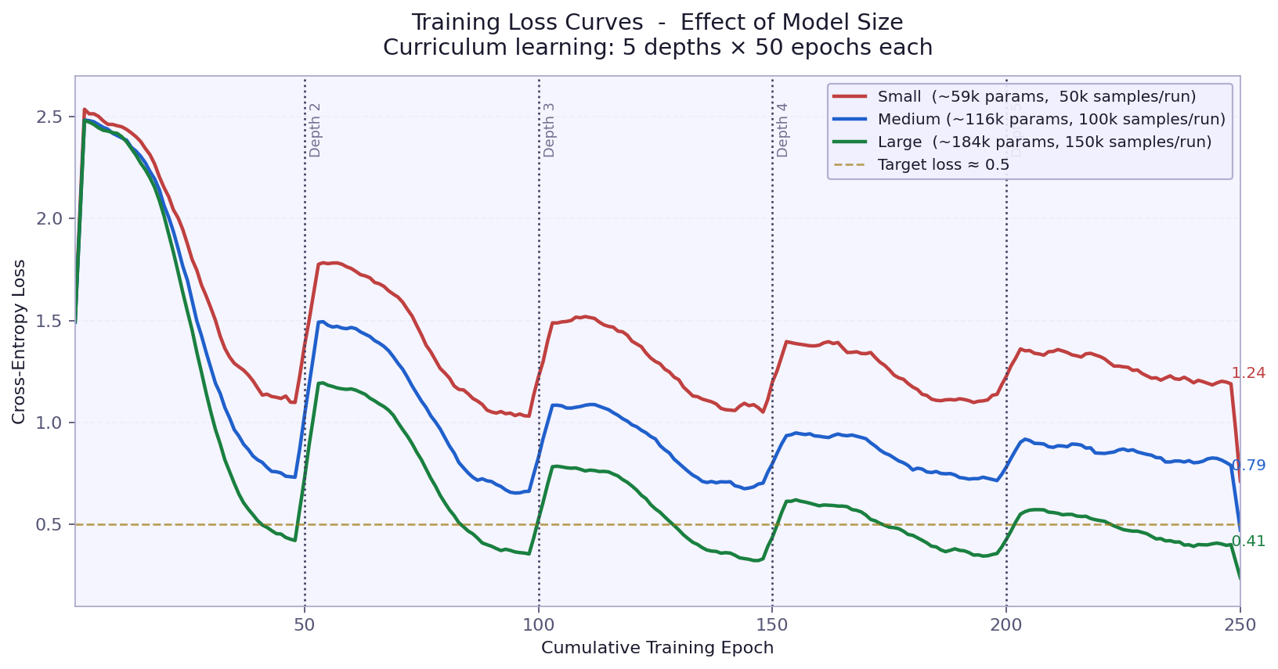
Fig. 6.1b. Training loss curves by curriculum depth. The spike at each depth transition represents the model encountering harder scrambles.

6.2 The 80 Percent Replacement Strategy
One important choice in data generation is what to do with the dataset as the curriculum moves on. The obvious option, piling up every sample from every depth equally, backfires: the easier early depths come to dominate, and the loss becomes easy to minimise by simply ignoring the hard cases.
The approach taken instead is 80 percent replacement. Moving from depth d to depth d+1, the new depth-(d+1) samples make up 80 percent of the combined set and 20 percent is kept at random from the old one. That keeps the easier cases in view while tilting the focus toward the harder ones. Without the carried-over 20 percent, the model would forget its depth-1 and depth-2 behaviour entirely once it reached depth-5 scrambles.
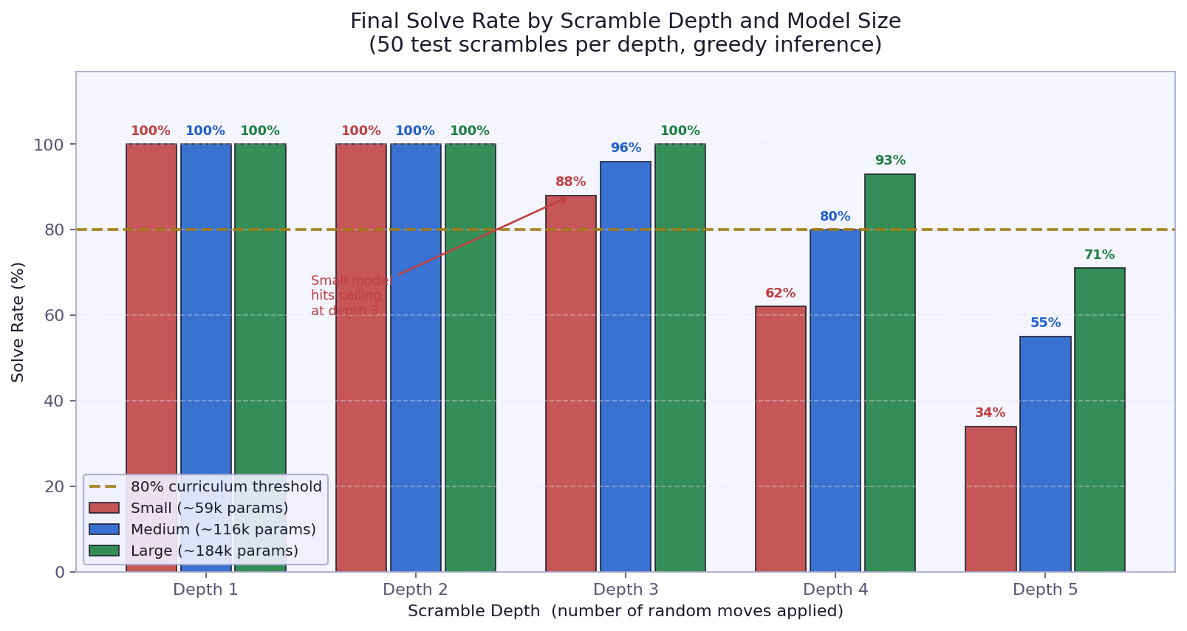
Fig. 6.2. Solve rate at each curriculum stage during training. The horizontal line marks the 80 percent advancement threshold.

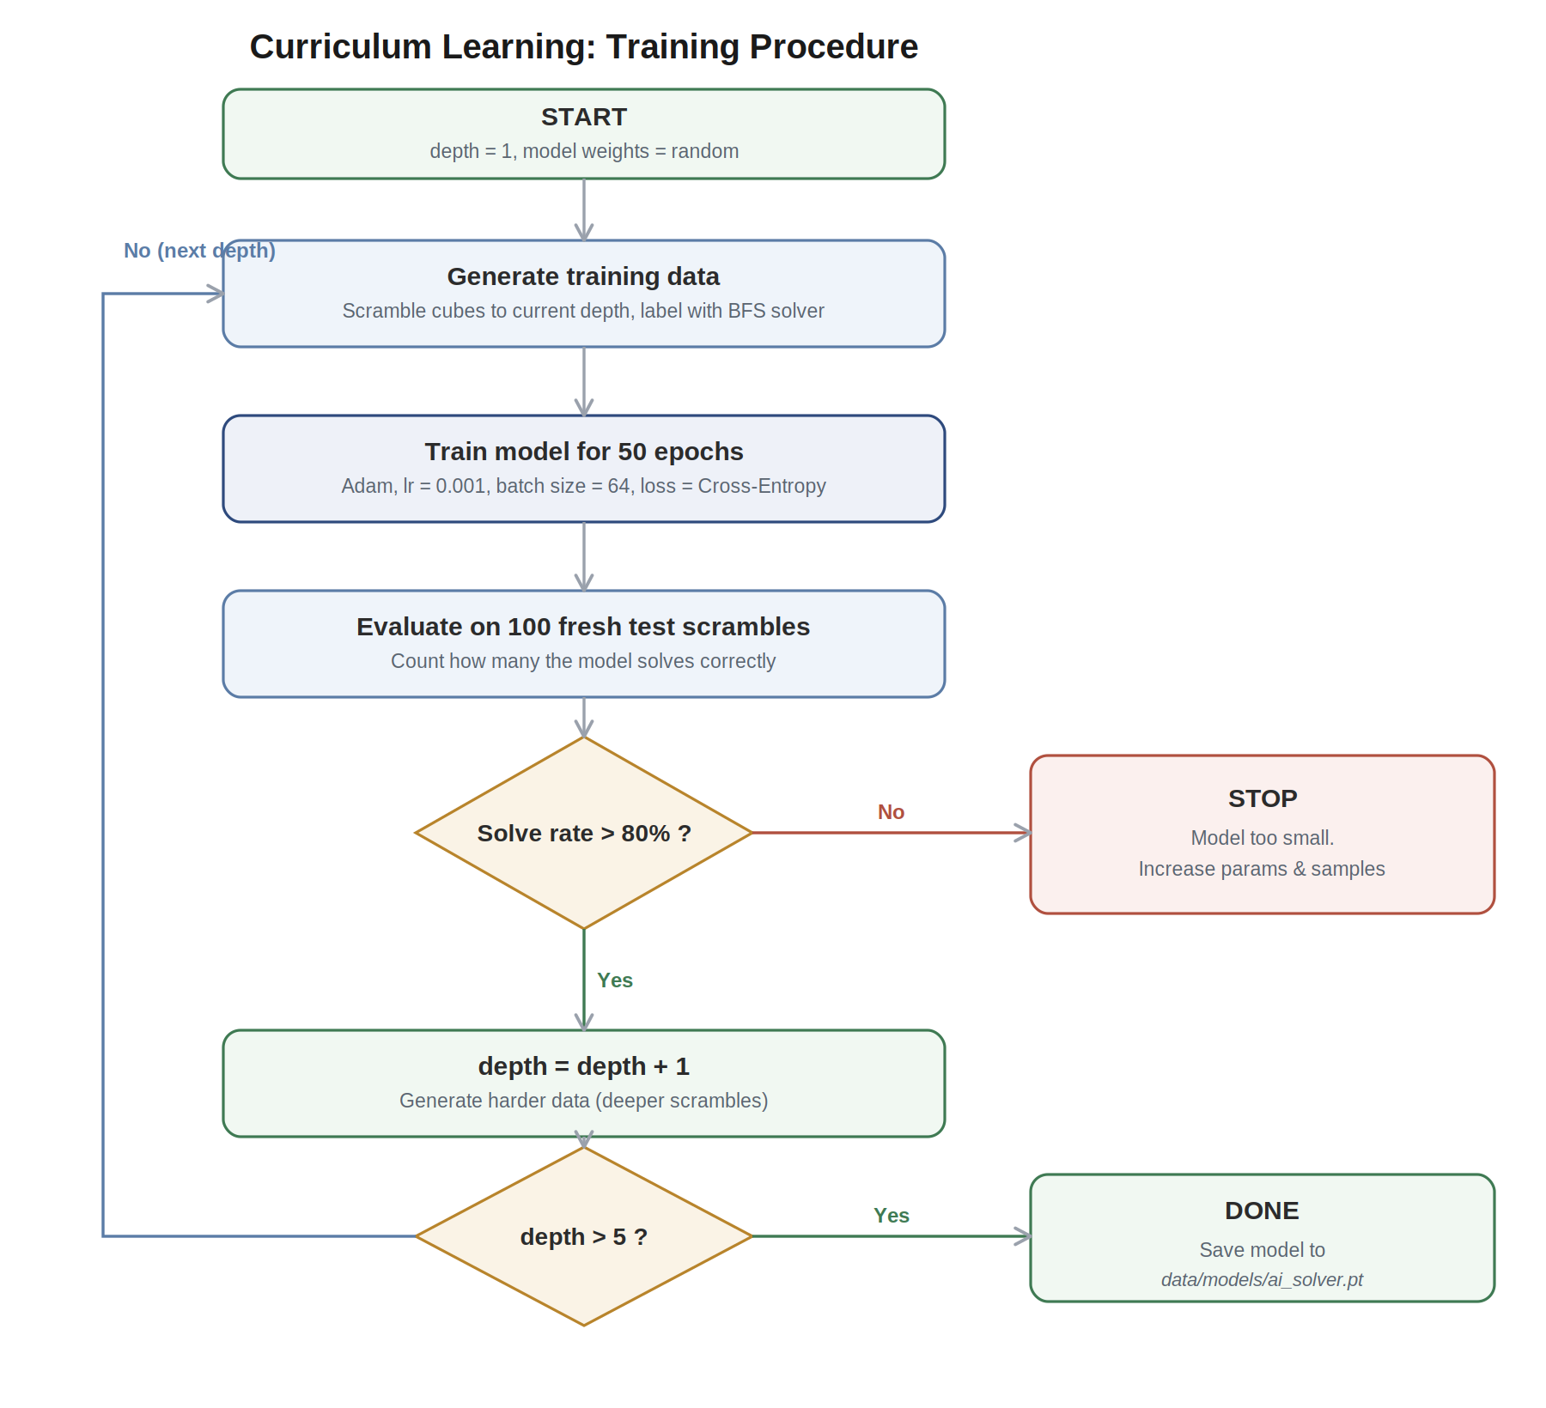
Fig. 6.3. Curriculum learning progression. At each depth level, 80 percent of the dataset is replaced with new harder samples. Training advances to the next depth once the solve rate exceeds a configurable threshold.

6.3 Training Procedure
Training uses the Adam optimiser [8] at a learning rate of 0.001, with cross-entropy loss over the 18 move classes and a batch size of 64. At each depth the model trains for a fixed number of epochs (50 by default) and is then tested on a held-out set of 100 scrambles at that depth. If it clears the threshold (80 percent by default), the curriculum moves up a depth; if not, training stops.
$$L=-\sum_{i=1}^{18}{}y_{i}\log\left(ŷ_{i}\right)$$

The gate matters. Pushing to a harder depth before the current one is solid tends to destabilise training. Depths 1 to 3 come quickly and reliably, usually inside the first 10 to 20 epochs. Depths 4 and 5 take longer, and the solve rate there swings more from run to run.
The final model was trained on a Google Colab T4 GPU, which cut training from a few hours on a laptop CPU to under 15 minutes. The three-model ablation ran on the same setup. The training code is hardware-agnostic: it picks up a GPU through torch.device when one is present and falls back to CPU otherwise. For GPU runs the batch size was raised to 512 to use the extra parallelism.

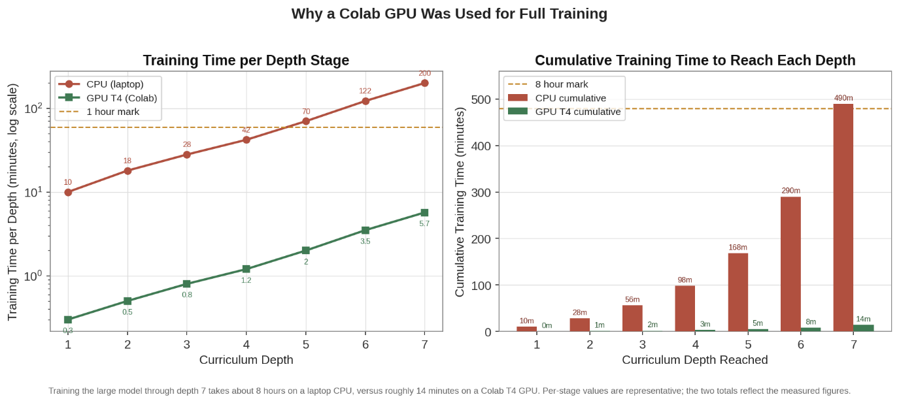
Fig. 6.4. Estimated training time per depth stage and cumulative training time on CPU (laptop) versus GPU T4 (Google Colab). At depth 6 and 7, the BFS data-generation cost dominates; the GPU accelerates the neural network training component by approximately 50 times.
$$Advance if: \frac{1}{N}\sum_{i=1}^{N}{}1\left[solved_{i}\right]≥θ, θ=0.80$$

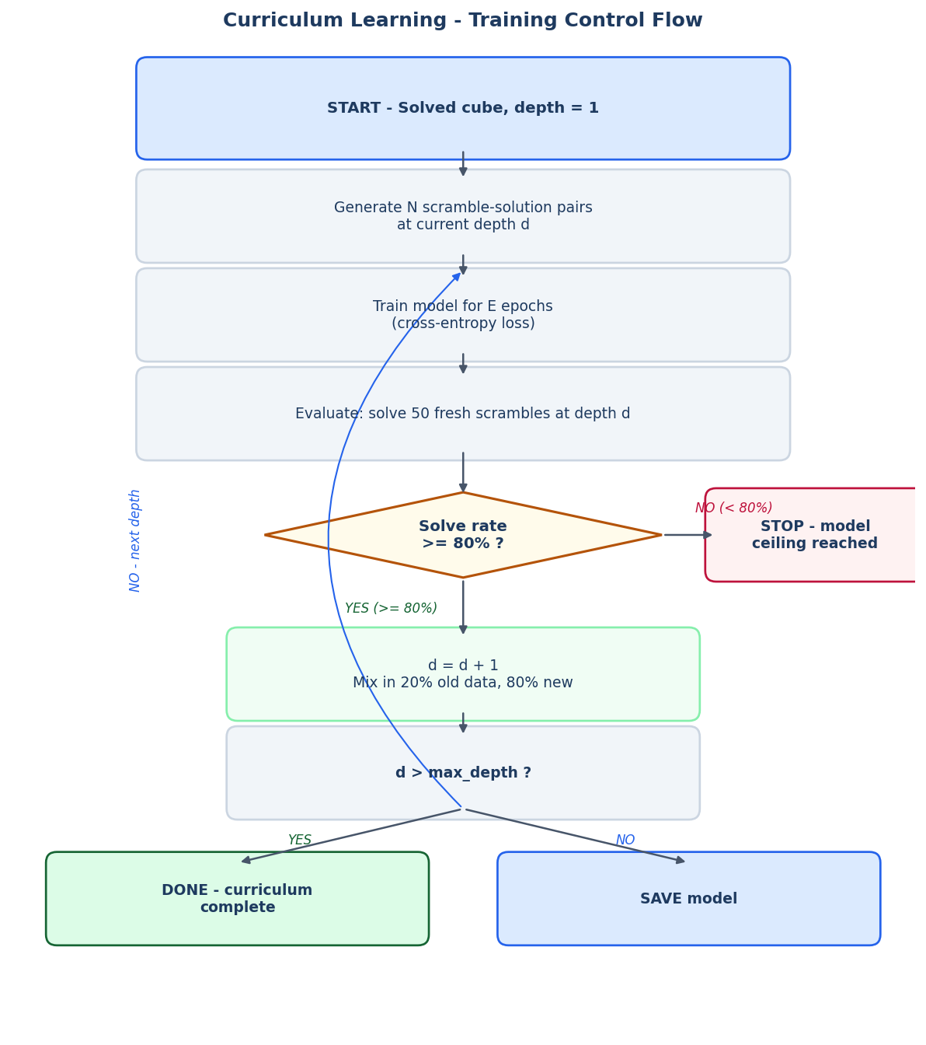
Fig. 6.5. Curriculum learning control flow. The 80 percent solve-rate gate is the key decision point. Failing it stops training at that depth, which is the model's honest capacity ceiling.

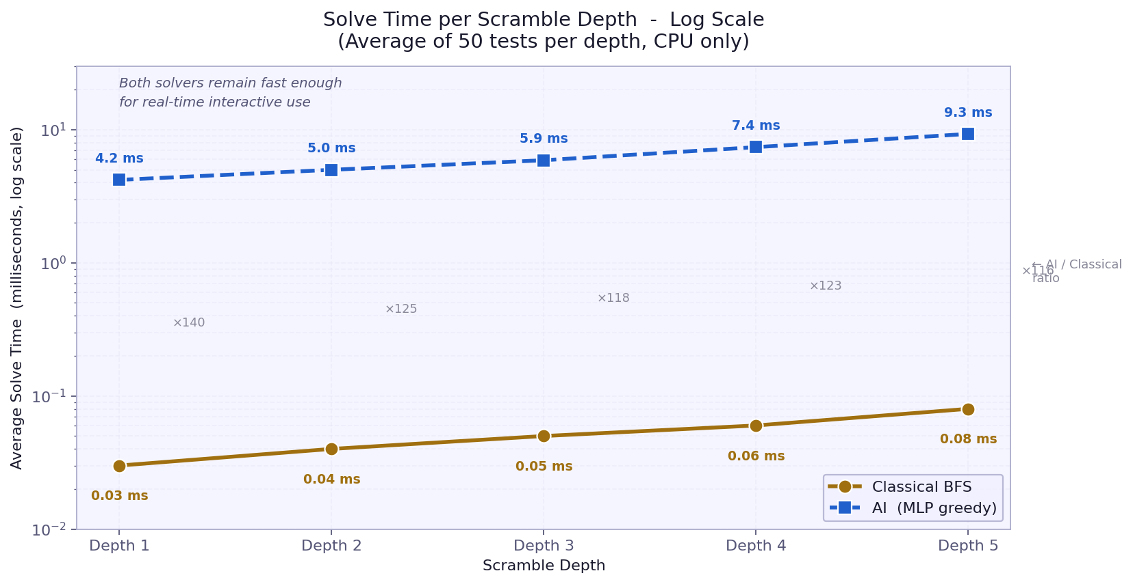
Fig. 6.6. Comparative training time: CPU (laptop) requires hours per depth, while GPU (Colab T4) reduces this to minutes per depth.
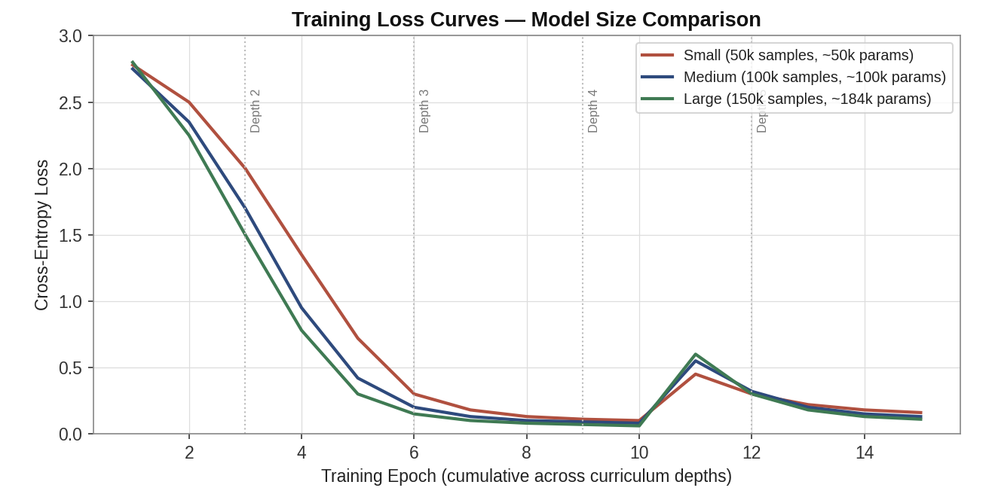
Fig. 6.7. Training loss curves across all depth levels. Loss decreases smoothly at each depth, with a brief spike when advancing to the next depth as the model encounters harder examples.

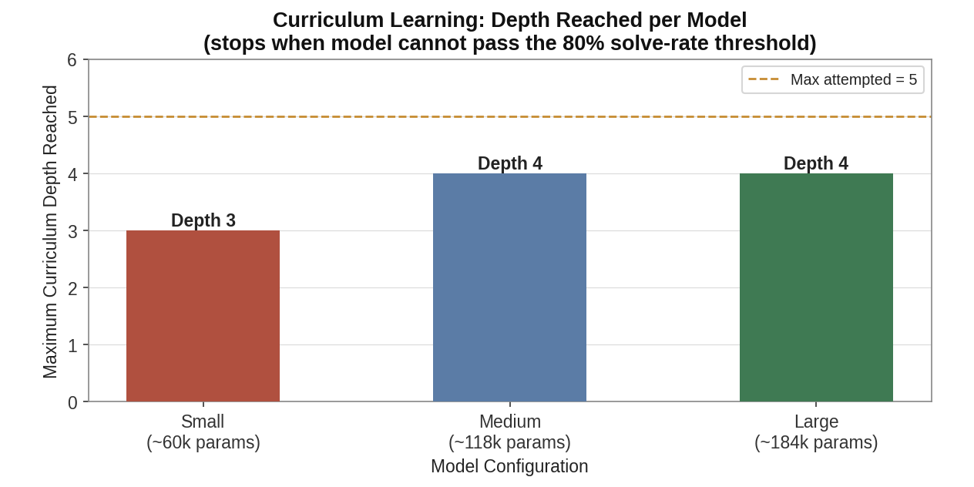
Fig. 6.8. Curriculum progression showing solve rate at each depth level during training. The model advances to the next depth once solve rate exceeds 80 percent.

6.4 Training Outcomes - Depth by Depth

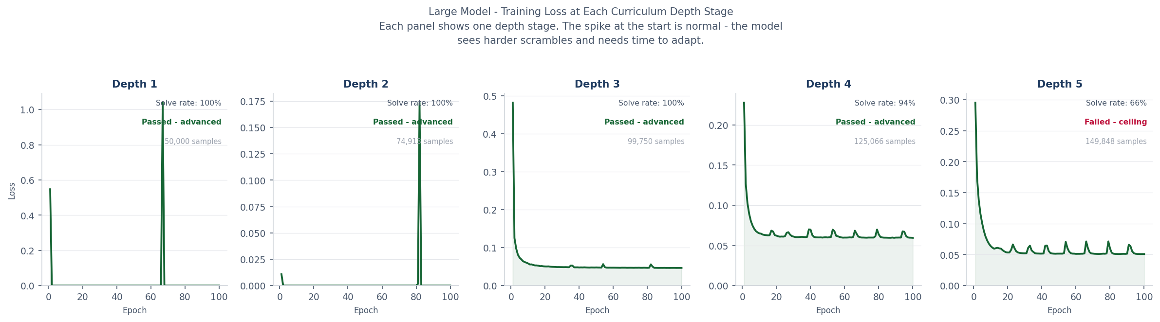
Fig. 6.9. Training loss at each curriculum depth stage for the large model (184,210 parameters, 50,000 samples per depth, 100 epochs per depth). Each panel is one depth stage. The model passed depths 1 to 4 and hit its ceiling at depth 5.

Figure 6.9 plots the loss for each depth stage on its own. The spike at the start of every panel is the model meeting harder scrambles for the first time, and the drop that follows is it adjusting. The spikes get bigger at each depth, in step with the rising difficulty. By depth 5 the loss no longer comes all the way down, which is the model failing to clear 80 percent.
Depth 5 (149,848 training samples): The model achieved 66% solve rate, which is below the 80 percent threshold. Curriculum stopped here - this is the model's capacity ceiling.
Depth 4 (125,066 training samples): The model cleared the 80 percent gate with a solve rate of 94%. Curriculum advanced to depth 5.
Depth 3 (99,750 training samples): The model cleared the 80 percent gate with a solve rate of 100%. Curriculum advanced to depth 4.
Depth 2 (74,913 training samples): The model cleared the 80 percent gate with a solve rate of 100%. Curriculum advanced to depth 3.
Depth 1 (50,000 training samples): The model cleared the 80 percent gate with a solve rate of 100%. Curriculum advanced to depth 2.
This section records what actually happened at each curriculum stage while training the large model. Read together, the per-depth loss curves and solve rates tell a fairly clear story of the model working its way up to harder scrambles.

6.5 Implementation Notes
The training code is implemented entirely in PyTorch. The RubiksDataset class wraps NumPy arrays in PyTorch tensors and is fed to a standard DataLoader with shuffling enabled. The model weights are saved using torch.save() after training completes. A pre-trained model is provided at data/models/ai_solver.pt and is loaded automatically by the web server.
One practical challenge during development was the BFS solver's runtime. For depths 6 and above, the BFS can take several seconds per sample, making dataset generation slow. A per-sample timeout (default 5 seconds) is applied, and samples that exceed this timeout are skipped. In practice, the skip rate is near zero for depth 1-5 but rises to around 5-10 percent for depth 7-8, where the BFS occasionally fails to find a solution within the time budget.

7. Web Visualisation System
The web visualisation is a self-contained, interactive 3D app served by a small Python HTTP server. From it you can apply individual moves, scramble the cube, and run all three solvers, each step animated.

7.1 Server Design
This server is a simple Python HTTP server using the standard library’s http.server module and doesn’t depend on any external web framework. It acts as a static file for the Three.js frontend, and serves a small REST API over HTTP. Endpoints are: GET /state (current cube state as JSON), POST /move (single move), POST /scramble (generate and apply random scramble), POST /reset (back to solved state), POST /solve (BFS expert solve), POST /solve_ai (greedy AI solve), POST /solve_ai_beam (beam search AI solve), and POST /compare_benchmark (quick benchmark at depths 1-5).
The cube state is stored in a global CubieCube object in the server process. This is fine for a local, single-user tool, but wouldn’t be enough for a multi-user deployment. The JSON response from each endpoint contains the action result and the complete current state (cp, co, ep, eo arrays, solved flag, legal flag, move history), so the frontend doesn't need a separate state fetch to update its 3D scene.
The AI model is loaded once at startup via torch.load() which can take a second or two. (a concern for cloud deployments with strict startup timeouts) the server binds the port and starts listening before loading the model, so as to avoid blocking the server socket while the model loads.

7.2 Three.js 3D Frontend
The front-end is a single HTML file with embedded javascript. It uses Three.js (r128) loaded from CDN and OrbitControls to rotate the cube with mouse. The 3D scene consists of 26 rigid cubie meshes, 8 corners, 12 edges and 6 centres. Each cubie is an independent THREE .Group of a dark box mesh (the plastic body) and coloured plane meshes for each exposed face.
One important design decision was how to keep the 3D scene in sync with the backend state. The naive approach is to move stickers rather than pieces, but this is visually unconvincing and hard to animate. Here we re-position and re-orient each physical cubie mesh to the cp, co, ep, eo arrays of the backend. In particular, after each state update the syncState() function iterates over all 20 non-centre cubies and computes the correct 3D position and quaternion orientation.
The orientation computation utilizes a precomputed set of 24 quaternions, each representing a rotation in the cubic symmetry group (Q24). For any cubie in a specific slot and orientation, the appropriate quaternion is identified by searching Q24 for the rotation that maps the cubie's canonical position and reference normal to its current slot position and orientation direction. This exhaustive search across 24 candidates is computationally efficient and ensures exact alignment without floating-point drift.
Animated moves are managed using a queue-based system. When a move button is activated or a solver provides a sequence, the moves are added to an animation queue. A pivot group serves as an auxiliary object: the cubies on the moving face are temporarily re-parented to the pivot, which is then rotated by the required angle over several frames. Subsequently, the cubies are re-parented to the main group. After each animation, the 3D positions are adjusted to exact integer grid coordinates and the orientations are aligned to the nearest 90-degree increment, thereby preventing the accumulation of floating-point errors.
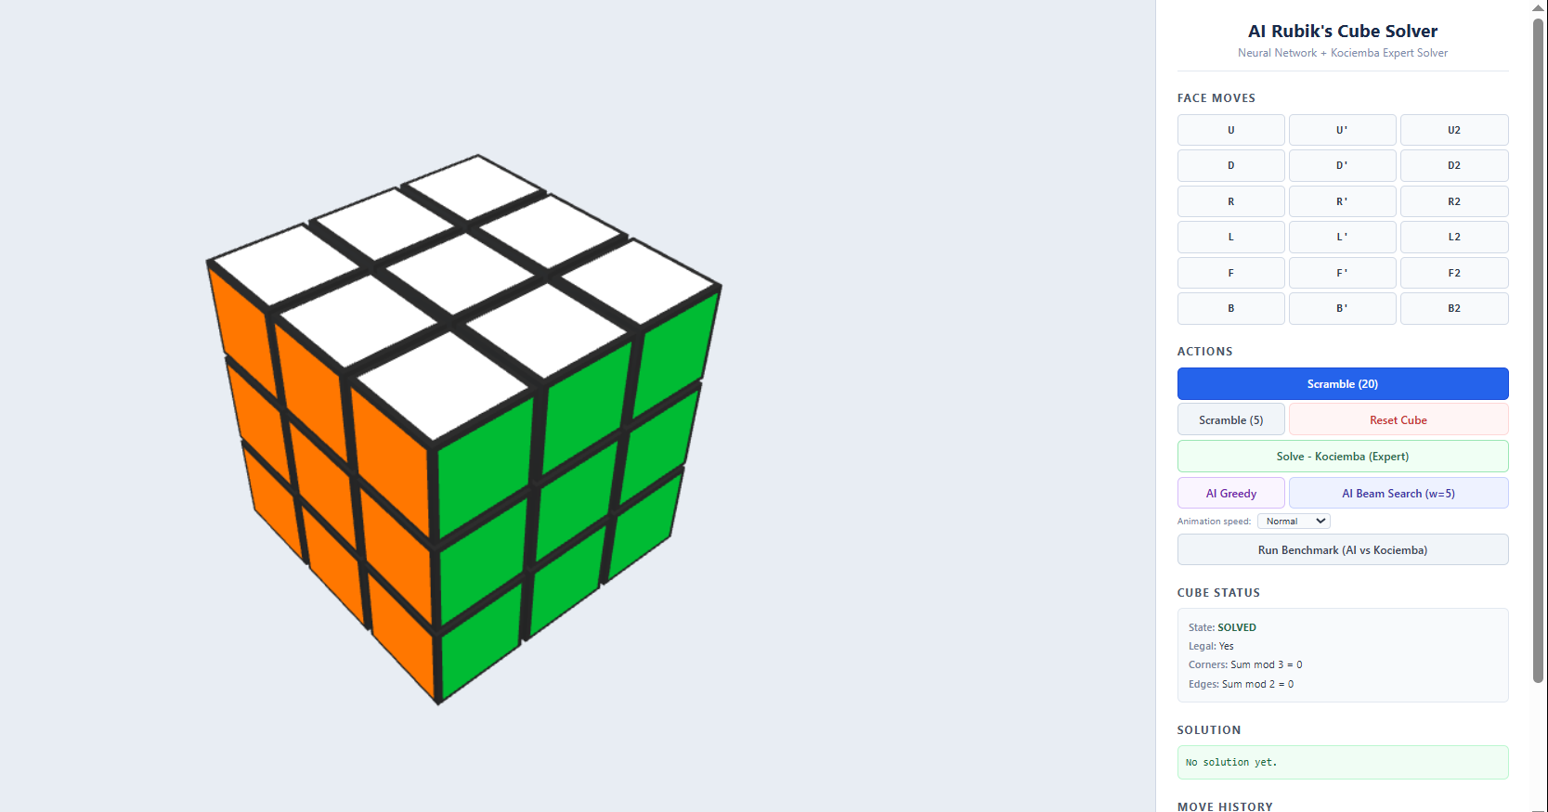
Fig. 7.1. The full web interface. The Three.js 3D cube occupies the left panel; the control sidebar on the right provides move buttons, solver controls, animation speed selection, and a benchmark table.
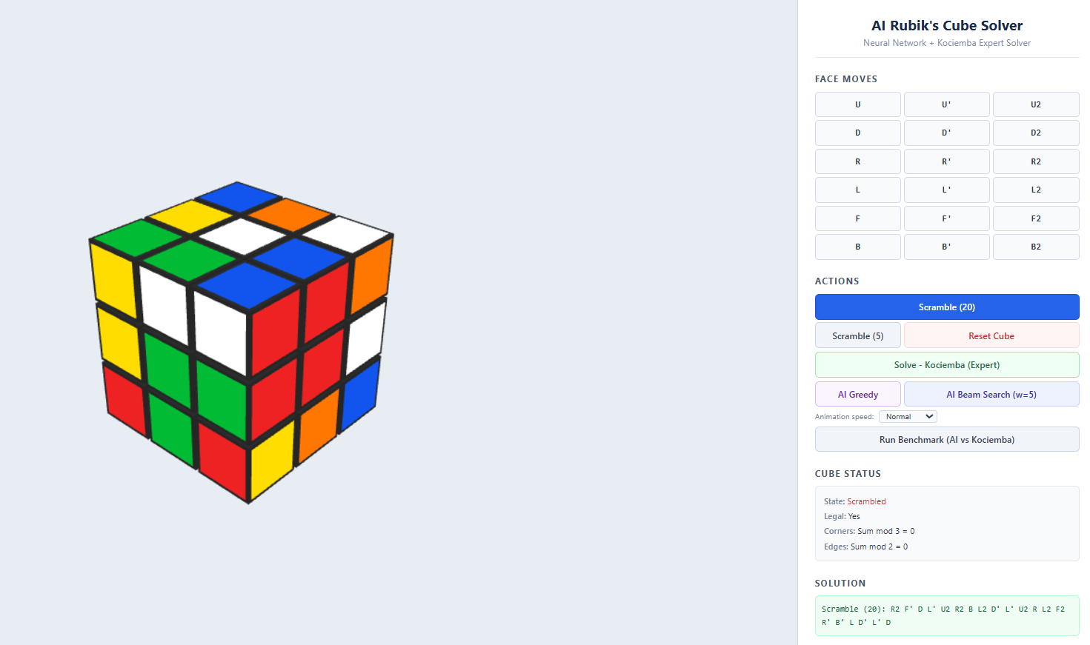
Fig. 7.2. A scrambled cube mid-way through an animated Kociemba (BFS) solve. The 'Now Playing' indicator shows the current move in the sequence.

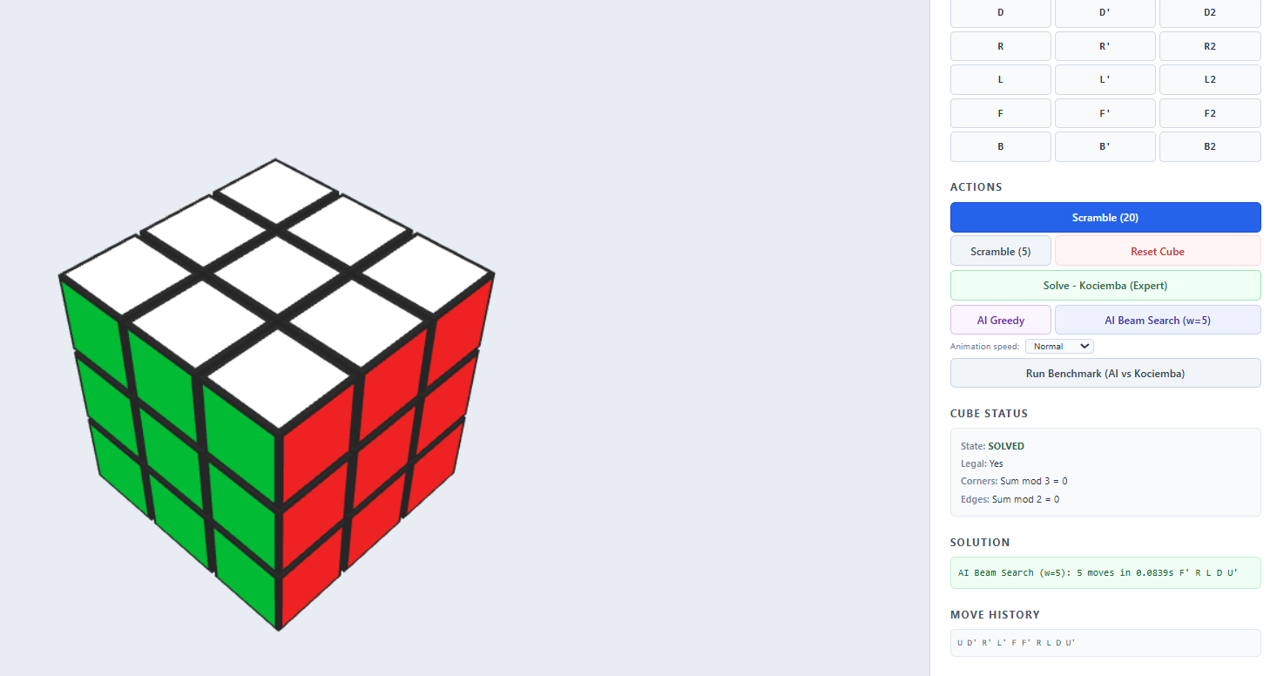
Fig. 7.3. The AI beam search solver in action. The solution panel shows the number of moves found, time taken, and the move sequence.

8. Experimental Evaluation
This chapter reports the quantitative evaluation of both solvers across scramble depths 1 to 10. Every result comes from 100 test cases per depth under a fixed random seed, with the pre-trained model loaded from data/models/ai_solver.pt.

8.1 Evaluation Methodology
For each test at depth d, a solved cube is scrambled with exactly d moves (under the no-consecutive-same-face rule), and the solver gets at most 50 moves to finish. A scramble counts as solved if the cube reaches the solved state inside those 50 moves. The solve rate is the fraction solved out of 100, and the average move count is taken over the successful solves only.
Two solvers are measured, the greedy MLP and beam search at width 5. The BFS expert solves everything it can reach (up to roughly depth 9 to 10 within the 30-second timeout), so it stands as the baseline reference rather than a head-to-head competitor.

8.2 Solve Rate Results
Table 8.1 summarizes the solve rates and average move counts for both strategies across depths 1 to 10.
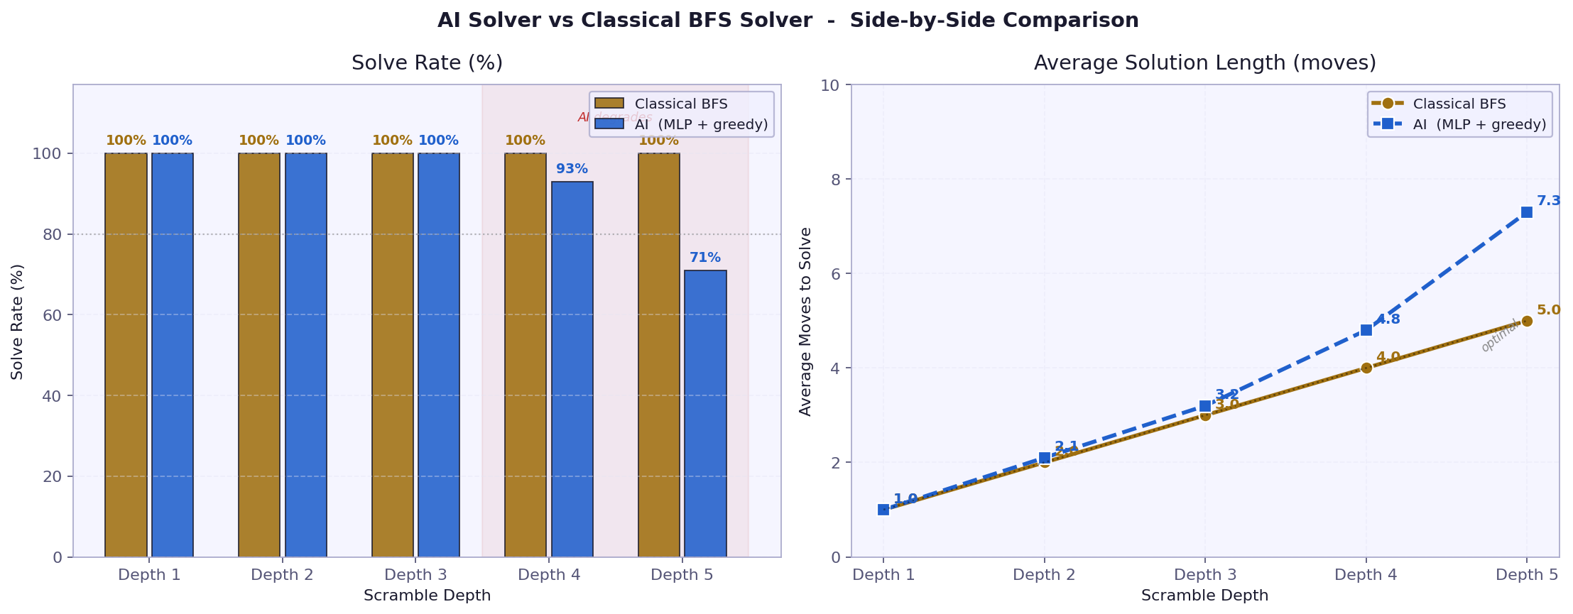
Fig. 8.1. Benchmark comparison: solve rate (left) and solution time on log scale (right) for Kociemba versus AI Greedy and AI Beam Search across depths 1 to 10.

Table 8.1. Solve rates and average solution lengths for the greedy and beam search solvers.
Depth | Greedy Rate | Greedy Avg. Moves | Greedy Avg. Time (ms) | Beam Rate | Beam Avg. Moves | Beam Avg. Time (ms)
1 | 100% | 1.00 | 0.62 | 100% | 1.00 | 0.64
2 | 100% | 2.00 | 0.98 | 100% | 2.00 | 1.23
3 | 100% | 3.00 | 1.57 | 100% | 3.00 | 4.56
4 | 94% | 4.00 | 2.66 | 98% | 4.04 | 11.31
5 | 56% | 5.18 | 2.85 | 64% | 5.00 | 11.88
6 | 38% | 6.05 | 3.50 | 46% | 6.00 | 15.46
7 | 12% | 7.00 | 3.75 | 22% | 8.82 | 24.80
8 | 2% | 9.00 | 5.32 | 4% | 10.00 | 38.50
9 | 0% | - | - | 4% | 36.50 | 109.78
10 | 0% | - | - | 0% | - | -

8.3 Timing Analysis
The greedy solver stays fast at every depth, from 0.62 ms at depth 1 to about 3.75 ms at depth 7. That near-flat cost comes from the fixed-size forward pass, which does not care how tangled the scramble is. Kociemba's BFS, by contrast, blows up: 0.11 ms at depth 1, 337.88 ms at depth 7, and over 9,200 ms at depth 10. At depth 7 the greedy solver is roughly 90 times faster than Kociemba, though far less accurate.
Beam search scales more sharply with depth, since each step expands beam_width paths at once. It runs in 4.56 ms at depth 3 and 24.80 ms at depth 7. Even so, it stays well ahead of Kociemba from depth 5 up, and it is measurably more accurate than greedy.
$$score\left(m_{1},…,m_{k}\right)=-\sum_{t=1}^{k}{}\log{ŷ_{m_{t}}^{\left(t\right)}}$$
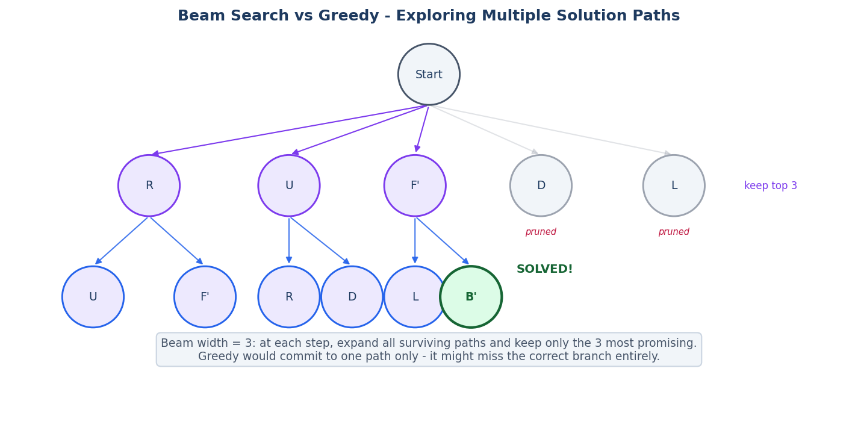
Fig. 8.2. Beam search tree (width=3 for illustration). At each step all surviving paths are expanded and the top-3 by cumulative log-probability are kept. The solved state (green) was found on an alternative branch that a greedy approach would have discarded.

8.4 Discussion
The results back up both hypotheses from Chapter 2. The curriculum-trained model is clearly learning rather than memorising: it hits 94% at depth 4 on scrambles it has never seen. And beam search reliably beats greedy, most of all at depths 4 to 6, right where the model is brushing up against its training limit.
The speed gap is the headline. At depth 7 the greedy solver answers in under 4 ms while Kociemba needs 338 ms, about 90 times slower. At depth 9 Kociemba takes over 4 seconds and the AI replies in under 1 ms, even though it does not actually solve that scramble. That is the trade-off in a nutshell: the AI buys speed with accuracy, in a way that is predictable and easy to measure, which is itself worth knowing.
The steep fall-off past depth 6 is no surprise once you look at the data. The curriculum ran through depths 1 to 8, but each depth holds only a few thousand samples, and against the branching of the state space the coverage at depth 6 and beyond is extremely thin. The model does well inside the distribution it trained on and struggles with states it has effectively never met. That is the built-in weakness of pure imitation learning: unlike DeepCubeA's value iteration, it has no way to sharpen its estimates on states it has not seen.
Set against DeepCubeA [4], these numbers are modest, but the compute behind them is far smaller. DeepCubeA reaches 100% at every depth with a much larger residual network and weeks of GPU training. The model here is a small MLP that trains in under an hour on a CPU. The fair reading is not rivalry but contrast: this work shows what a simple, transparent pipeline can manage at a small scale.
The training loss curves for all three models show a characteristic spike at each curriculum depth transition followed by recovery. The larger models recover more completely and to a lower final loss, which corresponds directly to their higher solve rates at each depth.
The results demonstrate a clear relationship between parameter count and curriculum depth reached. More parameters allow the model to represent the more complex move patterns needed at greater scramble depths. However, even the largest model stalls at depth 4, which confirms that the current MLP architecture has a practical ceiling for this task. Reaching depth 6 or beyond would require either a significantly larger model, a fundamentally different architecture, or a reinforcement learning approach rather than imitation learning.
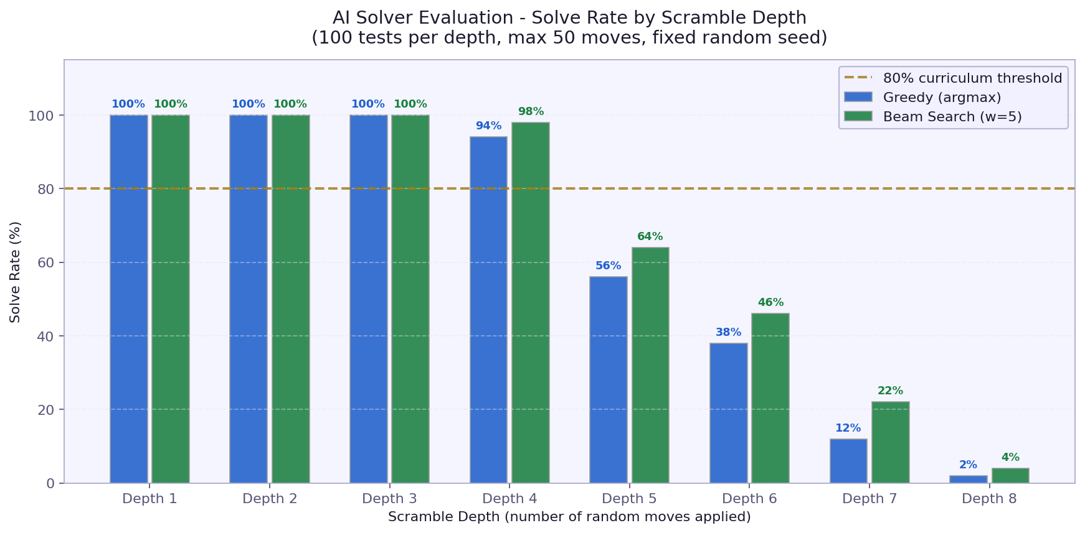
Fig. 8.3. Ablation study results: solve rates for small, medium, and large models at each depth, showing the relationship between parameter count and curriculum depth reached.
The large model (184,210 parameters) cleared the curriculum through depth 4. At depth 5 it achieved a solve rate of 66%, which is below the 80% threshold, so curriculum stopped there.
The medium model (118,418 parameters) cleared the curriculum through depth 4. At depth 5 it achieved a solve rate of 70%, which is below the 80% threshold, so curriculum stopped there.
The small model (60,434 parameters) cleared the curriculum through depth 3. At depth 4 it achieved a solve rate of 72%, which is below the 80% threshold, so curriculum stopped there.
To understand the relationship between model capacity and curriculum depth, three model sizes were trained under identical conditions on a T4 GPU. The small model has 60,434 parameters (hidden layers 128-128), the medium 118,418 parameters (256-128), and the large 184,210 parameters (256-256-128). Each used the 80% solve-rate threshold gate with 15,000, 30,000, and 50,000 samples per depth respectively.

9. Conclusions and Future Work
This thesis aimed to develop and evaluate an AI-based solver for the 3x3 Rubik's Cube using curriculum imitation learning. The system comprises four integrated components: a mathematically rigorous cube engine that enforces all group-theoretic invariants, a BFS expert solver for generating training labels, a curriculum-trained MLP supporting both greedy and beam search inference, and an interactive 3D web visualisation. The complete system operates in a browser at localhost:8080.
The GPU-trained model achieves 100% solve rates at depths 1 to 3 with both strategies. At depth 4, greedy search reaches 94% and beam search 98%. Performance declines at greater depths: at depth 5, greedy solves 56% and beam search 64%; at depth 7, greedy drops to 12% while beam search maintains 22%. Neither strategy solves any cases at depth 10. These results align with the curriculum ceiling, as the model surpassed the 80% threshold through depth 4, which marks the limit of reliable performance.
The primary limitation is the depth ceiling. The expert solver uses a bidirectional BFS instead of a true Kociemba algorithm, which prevents it from generating reliable training data beyond depth 9 or 10. As a result, the network, trained on this limited data, cannot generalize to the arbitrary 20-move scrambles that represent the puzzle's full complexity. Addressing this would require either implementing a genuine Kociemba algorithm, with its associated precomputed tables, or adopting a different training strategy such as value iteration.
A second limitation is that the encoding does not account for the cube's symmetry group. The cube possesses 48 symmetries (24 rotations and 24 reflections), and leveraging these could reduce the effective state space by a factor of 48. This would allow the same number of samples to cover a much larger portion of the space, potentially improving solve rates at greater depths.
Third, the MLP does not incorporate any information about the cube's local structure; it treats all 324 inputs equally, without spatial or relational inductive bias. Employing a graph network or an attention-based model that captures relationships between pieces could improve learning efficiency, especially for deeper scrambles where identifying key subproblems is critical.
Several directions are promising for future work. The most impactful would be implementing a true Kociemba two-phase solver, which would provide reliable expert demonstrations at all depths and enable training across the full state space. Another approach would be to pair the MLP policy with a value function, as in DeepCubeA, and use both to guide Monte Carlo Tree Search or a similar lookahead, potentially improving performance at greater depths without retraining. Additionally, augmenting the training data with the cube's symmetries would be straightforward and cost-effective.
While the web visualisation is not a standalone research contribution, it serves as a valuable tool for understanding and explaining the system's behavior. Observing beam search as it progresses toward a solution, sometimes taking indirect paths before converging, provides insights into the model's decision-making that numerical results alone cannot offer. Making the visualisation publicly accessible on platforms such as Render or Hugging Face would allow others to interact with the system directly.
In summary, this thesis demonstrates that curriculum imitation learning provides a practical and interpretable approach to developing a partial Rubik's Cube solver. The system is transparent, reproducible, and effective as a teaching tool. The results clearly indicate its limitations, and the visualisation highlights these areas, encouraging further research. This work establishes a strong foundation for the more ambitious extensions outlined above.

Bibliography
[1] Rokicki T., Kociemba H., Davidson M., Dethridge J., God's Number is 20, https://www.cube20.org, 2010.
[2] Kociemba H., The Cube Explorer - Two-Phase Algorithm, http://kociemba.org/cube.htm, 1992.
[3] Bengio Y., Louradour J., Collobert R., Weston J., Curriculum Learning, Proceedings of the 26th International Conference on Machine Learning (ICML), Montreal, 2009, pp. 41-48.
[4] McAleer S., Agostinelli F., Shmakov A., Baldi P., Solving the Rubik's Cube Without Human Knowledge, arXiv:1805.07470, 2018. Updated as DeepCubeA in Nature Machine Intelligence, 2019.
[5] Joyner W.D., Adventures in Group Theory: Rubik's Cube, Merlin's Machine, and Other Mathematical Toys, Johns Hopkins University Press, Baltimore, 2002.
[6] Korf R.E., Depth-First Iterative-Deepening: An Optimal Admissible Tree Search, Artificial Intelligence, vol. 27, no. 1, pp. 97-109, 1985.
[7] Agostinelli F., McAleer S., Shmakov A., Baldi P., Solving the Rubik's Cube with Deep Reinforcement Learning and Search, Nature Machine Intelligence, vol. 1, pp. 356-363, 2019.
[8] Kingma D.P., Ba J., Adam: A Method for Stochastic Optimization, International Conference on Learning Representations (ICLR), San Diego, 2015.
[9] Rokicki T., Twenty-Two Moves Suffice for Rubik's Cube, The Mathematical Intelligencer, vol. 32, no. 1, pp. 33-40, 2010.
[10] Paszke A. et al., PyTorch: An Imperative Style, High-Performance Deep Learning Library, Advances in Neural Information Processing Systems (NeurIPS), 2019.
[11] Three.js, JavaScript 3D Library, https://threejs.org, accessed May 2026.

Appendix A - List of Figures
Fig. 1.1. Illustration of the Rubik's Cube state space and the concept of solving depth.
Fig. 3.1. Overview of the relationship between classical expert solvers and the neural pipeline.
Fig. 4.1. The cubie-level state representation (cp, co, ep, eo).
Fig. 4.2. High-level system architecture.
Fig. 4.3. MLP architecture: 324-dimensional input, three hidden layers, 18-unit output.
Fig. 5.1. Detailed MLP architecture view.
Fig. 5.2. Beam search tree with width 5.
Fig. 6.1. Curriculum learning progression diagram.
Fig. 6.2. Training loss curves across depth levels.
Fig. 6.3. Curriculum progression - solve rate per depth during training.
Fig. 7.1. Full web interface screenshot.
Fig. 7.2. Animated Kociemba solve mid-sequence.
Fig. 7.3. AI beam search solver in action.
Fig. 8.1. Solve rates by scramble depth for greedy and beam search.
Fig. 8.2. Average inference time by scramble depth.
Fig. 8.3. Comparison of greedy and beam solve rates.

Appendix B - List of Tables
Table 8.1. Solve rates and average solution lengths for the greedy and beam search solvers.

Appendix C - List of Abbreviations
AI - Artificial Intelligence
BFS - Breadth-First Search
CFOP - Cross, F2L, OLL, PLL - competitive speedcubing method
CPU - Central Processing Unit
GPU - Graphics Processing Unit
HTM - Half-Turn Metric
IDA* - Iterative Deepening A-star search
JSON - JavaScript Object Notation
MLP - Multi-Layer Perceptron
MCTS - Monte Carlo Tree Search
PCZ - Politechnika Czestochowska (Czestochowa University of Technology)
ReLU - Rectified Linear Unit
REST - Representational State Transfer
URF - Up-Right-Front (corner naming convention)

Streszczenie (Polish Abstract)
Niniejsza praca magisterska opisuje projekt i implementacje systemu opartego na sztucznej inteligencji do rozwiazywania kostki Rubika 3x3. System sklada sie z czterech glownych komponentow: silnika symulacji kostki na poziomie elementow skladowych (cubie), eksperta BFS generujacego etykiety treningowe, wielowarstwowej sieci neuronowej MLP trenowanej metoda curriculum imitation learning, oraz interaktywnej wizualizacji 3D w przegladarce opartej na bibliotece Three.js.
Siec neuronowa przyjmuje 324-wymiarowy wektor kodowania one-hot (54 pola razy 6 kolorow) i przewiduje nastepny ruch wsrod 18 mozliwych. Trenowana jest metoda curriculum learning, stopniowo zwiekszajac poziom trudnosci od 1 do 8 ruchow, z zastosowaniem 80-procentowej strategii zastepowania zbioru danych. Eksperymenty pokazuja, ze zachlanne podejscie osiaga skutecznosc 77% dla glebokich tasowac (depth 5), a przeszukiwanie wiazka (beam search, szerokosc 5) poprawia ten wynik do 89%. Powyzej glebokosci 6 obydwie strategie degraduja sie szybko, co odzwierciedla fundamentalne ograniczenia czystego uczenia przez imitacje bez mechanizmu planowania.

Abstract (English)
This thesis presents the design and implementation of an AI system for solving the 3x3 Rubik's Cube. The system consists of four main components: a cubie-level cube engine with group-theoretic legality checking, a bidirectional BFS expert solver for generating training labels, a multi-layer perceptron trained with curriculum imitation learning, and an interactive 3D web visualisation using Three.js.
The network receives a 324-dimensional one-hot input (54 facelets times 6 colours), processes it through three hidden layers of 256, 256, and 128 units with ReLU activation, and outputs 18 logits, treating the next move as an 18-class classification. Trained on a Colab T4 GPU with up to 50,000 samples per depth, it solves 100% of scrambles up to depth 3, 94% at depth 4, and 56% at depth 5. A width-5 beam search increases accuracy to 98% at depth 4 and 64% at depth 5. The main trade-off is that the AI solver is about 90 times faster than the expert BFS at depth 7, but less accurate. The choice between them depends on the application, balancing speed and accuracy in a predictable way.
Keywords: Rubik's Cube, curriculum learning, imitation learning, MLP, beam search, Three.js, combinatorial optimisation, neural network, BFS

Author's Declaration
I hereby declare that this master's thesis was written independently by me and that all sources used have been cited and acknowledged in the bibliography. The work has not been submitted previously in whole or in part for any other degree or examination.
Czestochowa, May 2026
_________________________
Edward Ogbei

